ASSIGNMENT
Large Language Models (CSE 4357)

Programme: B. Tech (CSE)
Semester: 7th

Full Marks: 20
Date of Submission: 20-12-2025
Subject/Course Learning Outcome | *Taxonomy Level | Question Nos. | Marks
Understand the fundamental concepts of language models, including tokenization and the representation of text as vector embedding for language processing | L2 | 1 | 2
Understand and explain the core mechanisms of the Transformer architecture used in modern large language models | L2 | 2 | 2
Develop skills to categorize and cluster text data using large language models for text classification and clustering tasks. | L2 | 3, 4 | 4
Apply dense retrieval, reranking and retrieval augmented generation methods to enhance traditional keyword-based search systems | L3 | 5, 6, 7 | 6
Develop the ability to work with multimodal LLMs by understanding image-to-vector transformations and applying them to visual reasoning tasks | L2 | 8 | 2
Understand and implement end-to-end adaptation of LLMs—including data preparation, task-specific fine-tuning, and performance assessment | L2 | 9, 10 | 4

*Bloom’s taxonomy levels: Knowledge (L1), Comprehension (L2), Application (L3), Analysis (L4), Evaluation (L5), Creation (L6).

Answer all questions. Each question carries equal mark.

- Assignment scores/markings depend on neatness, clarity and date of submission.
- Write your answers with enough detail about your approach and concepts used, so that the grader will be able to understand it easily.
- You are allowed to use only those concepts which are covered in the lecture class till date.

1. | Consider a small training corpus with word types and frequencies: low (5), lowest (2), newer (6), and wider (3). Using a SentencePiece tokenization procedure, perform 2 merge iterations and generate the sub-words. At each iteration:  - Compute Log- likelihood loss computation.  - Find the candidates for removal.  - Update the corpus representations and recompute the frequencies for the next iteration.  Ans: Given Corpus,  Total word tokens = 16  Initial Vocabulary  SentencePiece (Unigram LM) starts with a large vocabulary.  For simplicity, the initial vocabulary includes:  - Whole words: low, lowest, newer, wider  - Characters: l, o, w, e, s, t, n, r, i, d  Iteration 0 (Initial State)  Corpus Representation  low → low  lowest → lowest  newer → newer  wider → wider  Token Frequencies  Log-Likelihood Computation (Iteration 0)  Let  P(token) = frequency / 16  Log-likelihood:  L₀ = 5 log(5/16) + 2 log(2/16) + 6 log(6/16) + 3 log(3/16)  Iteration 1  Candidate Tokens for Removal  - lowest (frequency = 2)  Reason:  - Lowest frequency  - Can be decomposed into smaller subwords  lowest → low + e + s + t  Token Removed → lowest  Updated Corpus Representation  low → low  lowest → low e s t  newer → newer  wider → wider  Updated Token Frequencies  Log-Likelihood Computation (Iteration 1)  L₁ = 7 log P(low) + 6 log P(newer) + 3 log P(wider) + 2 [log P(e) + log P(s) + log P(t)]  Iteration 2  Candidate Tokens for Removal  - wider (frequency = 3)  Reason:  - Lower frequency compared to newer  - Can be decomposed into characters  wider → w + i + d + e + r  Token Removed → wider  Updated Corpus Representation  low → low  lowest → low e s t  newer → newer  wider → w i d e r  Updated Token Frequencies  Final Subword Vocabulary After 2 Iterations:  low  newer  w  i  d  e  r  s  t
  Word | Frequency
  low | 5
  lowest | 2
  newer | 6
  wider | 3
  Token | Frequency
  low | 5
  lowest | 2
  newer | 6
  wider | 3
  Token | Frequency
  low | 7
  e | 2
  s | 2
  t | 2
  newer | 6
  wider | 3
  Token | Frequency
  low | 7
  newer | 6
  w | 3
  i | 3
  d | 3
  e | 5
  r | 3
  s | 2
  t | 2

2. | Explain the Transformer architecture, focusing on the self-attention mechanism. Discuss the role of the Query (Q), Key (K), and Value (V) vectors  in computing the attention score for a token.  Ans: Transformer Architecture with Emphasis on Self-Attention  The Transformer is a neural network architecture designed for sequence modeling tasks such as machine translation and language modeling. Unlike RNNs or CNNs, the Transformer does not use recurrence or convolution. Instead, it relies entirely on self-attention mechanisms to model dependencies between tokens in a sequence.  The architecture consists of:  - Encoder: Stack of identical layers  - Decoder: Stack of identical layers  Each encoder layer contains:  - Multi-Head Self-Attention  - Position-wise Feed-Forward Network  Each decoder layer contains:  - Masked Multi-Head Self-Attention  - Encoder–Decoder Attention  - Position-wise Feed-Forward Network  Residual connections and layer normalization are applied around each sublayer.  Self-Attention Mechanism  Self-attention allows each token in a sequence to attend to all other tokens, including itself, in order to compute a context-aware representation.  For an input sequence of tokens:  x₁, x₂, x₃, …, xₙ  each token is projected into three vectors:  - Query (Q)  - Key (K)  - Value (V)  These vectors are learned linear transformations of the input embeddings.  Role of Query (Q), Key (K), and Value (V)  Query (Q)  - Represents what the current token is looking for  - Used to score relevance against all other tokens  Key (K)  - Represents what information each token contains  - Compared with the query to compute similarity  Value (V)  - Contains the actual information to be aggregated  - Weighted and summed to produce the final output  Computation of Attention Scores  Step 1: Linear Projections  For each token embedding  Q = xW_{Q}, K = xW_{K}, V = xW_{V}  where W_{Q}, W_{K}, W_{V}W_{Q}, W_{K}, W_{V} are learned parameter matrices.  Step 2: Scaled Dot-Product Attention  The attention score between a query and all keys is computed as:  Attention(Q, K, V) = softmax (QK^{T}/√d_{k})V  Where:  - QK^{T} computes similarity between query and keys  - d_{k} is the dimensionality of the key vectors  - Scaling by √d_{k} prevents large dot-product values  - Softmax converts scores into probabilities  Step 3: Weighted Sum of Values  Each value vector is weighted by its corresponding attention score and summed to produce the output representation for the token.  Interpretation of Self-Attention  - Tokens with higher relevance receive higher attention weights  - Each token dynamically builds a representation based on global context  - Enables modeling of long-range dependencies efficiently  - Parallel computation over all tokens (no sequential dependency)  Multi-Head Attention  Instead of computing a single attention function, the Transformer uses multiple attention heads:  - Each head learns different types of relationships  - Outputs are concatenated and linearly transformed  - Improves expressiveness and representation power  Key Advantages of Self-Attention  - Captures long-distance dependencies effectively  - Fully parallelizable  - Eliminates vanishing gradient issues of RNNs  - Scales well with large datasets

3. | Consider three document embeddings:  D1 = [0.1, 0.5, 0.9]  D2 = [0.2, 0.6, 0.8]  D3 = [0.9, 0.2, 0.4]  - Calculate pairwise Cosine similarity, Euclidean distance, and Dot product between all documents.  - Explain which similarity metric is generally preferred for clustering text embeddings in high-dimensional spaces.  Ans: Given Document Embeddings  D1 = [0.1, 0.5, 0.9]  D2 = [0.2, 0.6, 0.8]  D3 = [0.9, 0.2, 0.4]  (a) Pairwise Similarity Calculations  Step 1: Vector Norms  ‖D1‖ = √(0.1² + 0.5² + 0.9²)  ‖D1‖ = √(0.01 + 0.25 + 0.81) = √1.07 ≈ 1.034  ‖D2‖ = √(0.2² + 0.6² + 0.8²)  ‖D2‖ = √(0.04 + 0.36 + 0.64) = √1.04 ≈ 1.020  ‖D3‖ = √(0.9² + 0.2² + 0.4²)  ‖D3‖ = √(0.81 + 0.04 + 0.16) = √1.01 ≈ 1.005  - Dot Product  2. Cosine Similarity  Formula:  cos(θ) = (A · B) / (‖A‖ ‖B‖)  3. Euclidean Distance  Formula:  d(A,B) = √Σ(Aᵢ − Bᵢ)²  Summary Table  (b) Preferred Similarity Metric for Clustering Text Embeddings  Cosine similarity is generally preferred for clustering text embeddings in high-dimensional spaces.\  Reasons:  - Magnitude independence: Text embeddings often vary in length; cosine similarity focuses on direction, not vector size.  - Semantic relevance: Embedding models encode meaning in vector direction rather than absolute values.  - Curse of dimensionality: In high dimensions, Euclidean distances become less informative, while cosine similarity remains discriminative.  - Empirical standard: Most NLP clustering methods (e.g., document similarity, sentence embeddings) use cosine similarity by default.
  Pair | Dot Product
  D1 · D2 | (0.1×0.2) + (0.5×0.6) + (0.9×0.8) = 1.04
  D1 · D3 | (0.1×0.9) + (0.5×0.2) + (0.9×0.4) = 0.55
  D2 · D3 | (0.2×0.9) + (0.6×0.2) + (0.8×0.4) = 0.62
  Pair | Cosine Similarity
  D1, D2 | 1.04 / (1.034 × 1.020) ≈ 0.986
  D1, D3 | 0.55 / (1.034 × 1.005) ≈ 0.529
  D2, D3 | 0.62 / (1.020 × 1.005) ≈ 0.605
  Pair | Euclidean Distance
  D1, D2 | √[(−0.1)² + (−0.1)² + (0.1)²] = √0.03 ≈ 0.173
  D1, D3 | √[(−0.8)² + (0.3)² + (0.5)²] = √0.98 ≈ 0.990
  D2, D3 | √[(−0.7)² + (0.4)² + (0.4)²] = √0.81 = 0.900
  Pair | Dot Product | Cosine Similarity | Euclidean Distance
  D1 – D2 | 1.04 | 0.986 | 0.173
  D1 – D3 | 0.55 | 0.529 | 0.990
  D2 – D3 | 0.62 | 0.605 | 0.900

4. | Explain how prompting affects the performance of large language models and  provides examples of different types of prompting.  Ans: Effect of Prompting on Large Language Models  Prompting is the way input instructions are given to a large language model (LLM). Since LLMs generate outputs based entirely on the provided prompt, **the quality, clarity, and structure of the prompt directly affect model performance**. Well-designed prompts improve task understanding, reasoning accuracy, output format, and relevance, while vague prompts lead to incorrect or unfocused responses.  Prompting helps in:  - Clearly defining the task  - Controlling output structure and length  - Improving logical reasoning  - Reducing ambiguity and errors  Types of Prompting  1. Zero-Shot Prompting: Task given without examples.  Example: Translate the sentence into French.  - One-Shot Prompting: One example is provided before the task.  Example: Input: Good → Positive; Input: Bad → ?  3. Few-Shot Prompting: Multiple examples guide the model.  Example: Several labeled sentiment examples before classification.  4. Chain-of-Thought Prompting: Model is asked to explain reasoning step by step.  Example: Solve the problem step by step.  5. Instruction-Based Prompting: Direct command specifying the task.  Example: Summarize the paragraph in 3 points.

5. | Compare semantic search with keyword-based search in terms of scalability, accuracy, and computational cost. Provide one example where keyword search may still be preferable. What is the role of embeddings in semantic search pipelines? How do they capture meaning beyond keywords?  Ans: Semantic Search vs Keyword-Based Search  Example Where Keyword Search is Preferable  Legal or compliance search  When exact terms must match (e.g., searching for a specific clause number, regulation ID, error code, or API function name), keyword search is more reliable than semantic search.  Role of Embeddings in Semantic Search  Embeddings are dense numerical vector representations of text generated by neural models. They map words, sentences, or documents into a continuous vector space where semantically similar texts are close to each other, even if they share no exact keywords.  How Embeddings Capture Meaning Beyond Keywords  - Encode context, not just word presence  - Capture synonyms and paraphrases (e.g., “car” ≈ “automobile”)  - Preserve semantic relationships and intent  - Reduce language variability into geometric proximity in vector space  Example:  “cheap flights” and “low-cost airfare” have different keywords but similar embeddings.
  Aspect | Keyword-Based Search | Semantic Search
  Accuracy | Matches exact words or patterns; fails on synonyms and paraphrases | Understands intent and context; handles synonyms and rewording
  Scalability | Highly scalable using inverted indexes; works well on very large corpora | Scales with vector indexes (ANN), but requires embedding storage and indexing
  Computational Cost | Low at query time; simple string matching | Higher cost due to embedding generation and vector similarity computation

6. | How does the perplexity metric help in evaluating the quality of text generated by a language model? Explain briefly. Additionally, a language model assigns probabilities of 0.25, 0.10, 0.20, and 0.05 to a four-token sequence. Using these probabilities, calculate the perplexity of the model for  this sequence and show the formula and final numerical value.  Ans: Perplexity measures how well a language model predicts a sequence of tokens.  It is the inverse of the geometric mean of the predicted probabilities.  - Lower perplexity → better model  - Indicates less uncertainty in predicting the next token  - Commonly used to compare language models on the same dataset  Perplexity does not directly measure fluency or factual correctness, but it is a strong indicator of predictive quality.  Perplexity Formula  For a sequence of N tokens with probabilities p₁, p₂,…, p_{N}:  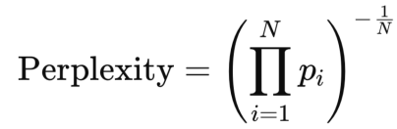  Given Probabilities  p₁ = 0.25  p₂ = 0.10  p₃ = 0.20  p₄ = 0.05  N = 4  Calculation  Product of probabilities: 0.25×0.10×0.20×0.05 = 0.00025  Perplexity:  PPL = (0.00025)^{−1/4}  ≈7.95  Perplexity ≈ 8

7. | The figure below shows the output of an information retrieval system on two queries. Crosses correspond to the relevant documents, dashes to non- relevant documents. Let the two documents contain 3 and 6 relevant documents, respectively, but only those shown in the figure are retrieved by the system, not the others.  - Calculate precision at K (where K=5)  - Compute the average precision(AP)  - Compute the mean average precision(MAP)  - Normalized Discounted Cumulative Gain (nDCG) (where relevance grade is binary)  Ans: Given  - Two queries: Q1 and Q2  - Relevant documents:  - Q1 has 3 relevant documents in total  - Q2 has 6 relevant documents in total  - Only the documents shown in the ranking are retrieved  - Relevance is binary (X = relevant, blank = non-relevant)  Retrieved Rankings  Q1  Relevant retrieved at ranks 1, 4, 5  Q2  Relevant retrieved at ranks 2, 4, 6, 7, 9  (a) Precision at K (K = 5)  Formula  P@5 = Relevant documents in top 5 / 5  Q1  Relevant in top 5 = 3  P@5(Q1) = 3/5 = 0.6  Q2  Relevant in top 5 = 2 (ranks 2 and 4)  P@5(Q2) = 2/5 = 0.4  (b) Average Precision (AP)  Formula  AP = (1/Total relevant documents) ∑P@k  AP for Q1 (Total relevant = 3)  AP(Q1) = (1.00+0.50+0.60) / 3 = 2.10/3 = 0.70  AP for Q2 (Total relevant = 6)  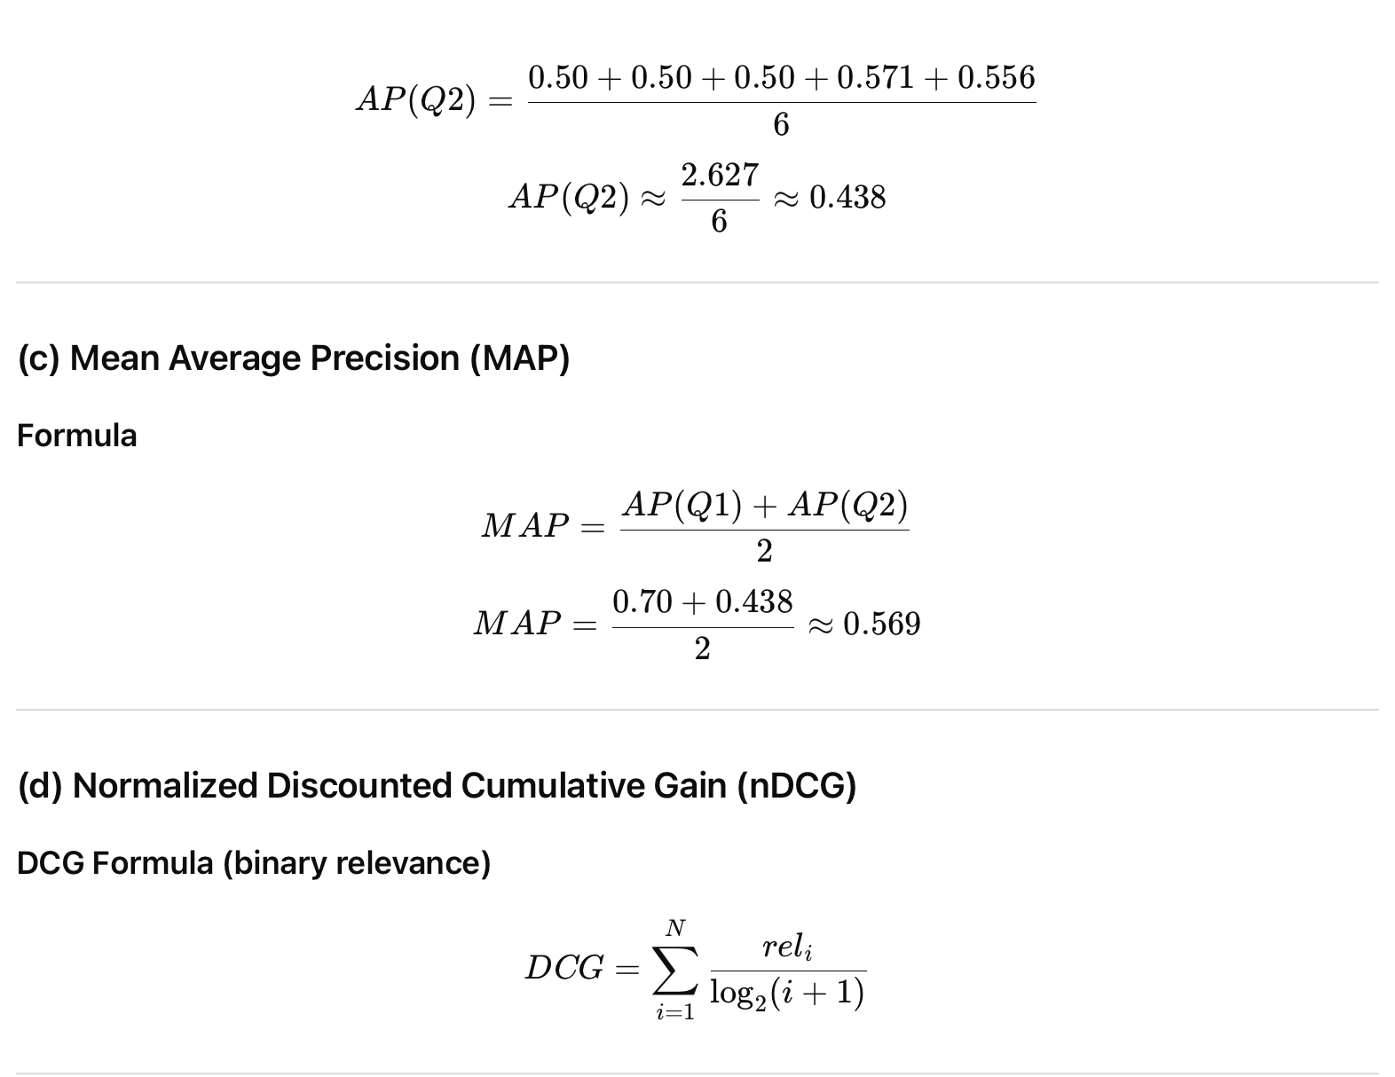  (c) Mean Average Precision (MAP)  Formula  (d) Normalized Discounted Cumulative Gain (nDCG)  DCG Formula (binary relevance)  nDCG for Q1  Relevant at ranks 1, 4, 5  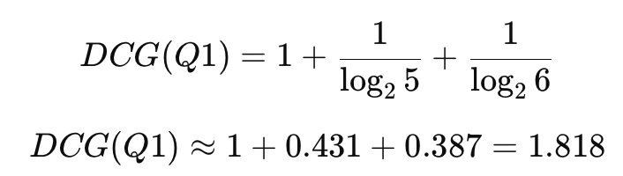  Ideal DCG (IDCG): all 3 relevant docs at top ranks (1,2,3)  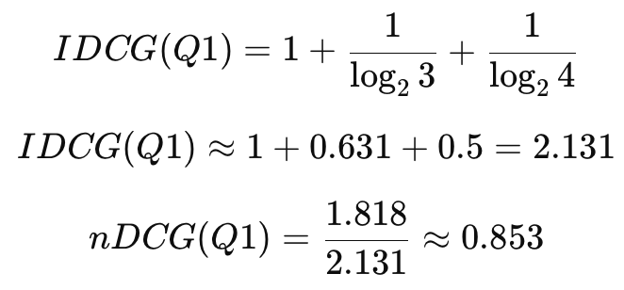  nDCG for Q2  Relevant at ranks 2, 4, 6, 7, 9  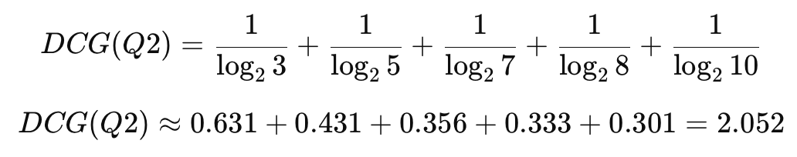  IDCG(Q2): 6 relevant docs ideally at ranks 1–6  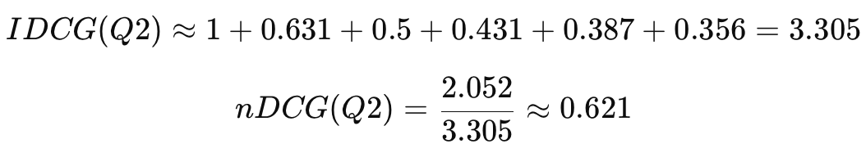  Final Answers Summary  MAP ≈ 0.569
  Rank | 1 | 2 | 3 | 4 | 5 | 6 | 7 | 8 | 9 | 10
  Q1 | X |  |  | X | X
  Q2 |  | X |  | X |  | X | X |  | X
  Rank | 1 | 2 | 3 | 4 | 5
  Relevance | X | – | – | X | X
  Rank | 1 | 2 | 3 | 4 | 5 | 6 | 7 | 8 | 9 | 10
  Relevance | – | X | – | X | – | X | X | – | X | –
  Rank | Relevant | Precision
  1 | Yes | 1/1 = 1.00
  4 | Yes | 2/4 = 0.50
  5 | Yes | 3/5 = 0.60
  Rank | Relevant | Precision
  2 | Yes | 1/2 = 0.50
  4 | Yes | 2/4 = 0.50
  6 | Yes | 3/6 = 0.50
  7 | Yes | 4/7 ≈ 0.571
  9 | Yes | 5/9 ≈ 0.556
  Metric | Q1 | Q2
  Precision@5 | 0.6 | 0.4
  Average Precision (AP) | 0.70 | 0.438
  nDCG | 0.853 | 0.621

8. | Explain what makes a language model “multimodal.” How does it differ from unimodal text-only LLMs?  Ans: A multimodal language model is a model that can process, understand, and generate information across multiple data modalities, such as text, images, audio, video, or structured data, within a single unified system.  What Makes a Model Multimodal  A language model is considered multimodal if it:  - Accepts non-text inputs (e.g., images, speech)  - Combines information from different modalities  - Produces outputs that depend on cross-modal understanding  Example:  Answering a question about an image or describing a scene shown in a picture.  Difference from Unimodal (Text-Only) LLMs
  Aspect | Unimodal LLM | Multimodal LLM
  Input | Text only | Text + image/audio/video
  Understanding | Linguistic patterns only | Cross-modal semantic understanding
  Output | Text | Text (conditioned on multiple modalities)
  Capability | Cannot interpret images or audio | Can reason over visual or auditory content

9. | State and compare sentence-level embeddings with document-level embeddings. Which would be more suitable for a legal search engine, and why?  Ans: Sentence-Level Embeddings: Sentence-level embeddings represent the meaning of individual sentences as dense vectors. They capture fine-grained semantics and are useful when precise phrasing or specific statements matter.  Characteristics:  - Short text units (sentences)  - High semantic precision  - Sensitive to wording and context  - Useful for question answering and clause matching  Document-Level Embeddings: Document-level embeddings represent the overall meaning of an entire document by aggregating information across multiple sentences or paragraphs.  Characteristics:  - Long text units (documents)  - Coarse, holistic representation  - Less sensitive to individual sentence details  - Useful for topic-level retrieval and clustering  Comparison  Suitable Choice for a Legal Search Engine  Sentence-level embeddings are more suitable.  Reason: Legal search requires exact clauses, obligations, definitions, and precedents, not just topic similarity. Sentence-level embeddings allow precise retrieval of relevant legal statements, while document-level embeddings may miss critical details by averaging meanings across the document.
  Aspect | Sentence-Level | Document-Level
  Granularity | Fine-grained | Coarse
  Text length | Short | Long
  Precision | High | Lower
  Context scope | Local | Global
  Typical use | QA, clause search | Topic search, clustering

10. | Explain the difference between fine-tuning, instruction-tuning, and RLHF.  How do these methods improve LLM performance and safety?  Ans: Fine-Tuning: Fine-tuning adapts a pre-trained language model to a specific task or domain by further training it on labeled data.  Purpose:  - Improve task accuracy  - Inject domain-specific knowledge (e.g., legal, medical)  Example:  Training a general LLM on legal documents for legal text analysis.  Instruction-Tuning: Instruction-tuning trains the model on instruction–response pairs so it learns to follow human-written commands.  Purpose:  - Improve instruction-following ability  - Make outputs more useful and structured  Example:  Training on prompts like “Summarize the text” → correct summary.  Reinforcement Learning from Human Feedback (RLHF): RLHF uses human preference judgments to guide the model’s behavior via reinforcement learning.  Purpose:  - Align outputs with human values  - Reduce harmful, biased, or unsafe responses  Example:  Humans rank model responses; preferred responses receive higher rewards.  Comparison  How They Improve Performance and Safety  - Fine-tuning improves factual accuracy in specific domains  - Instruction-tuning improves usability and controllability  - RLHF improves safety, reduces harmful outputs, and aligns responses with human expectations
  Aspect | Fine-Tuning | Instruction-Tuning | RLHF
  Training Signal | Labeled data | Instructions + responses | Human preferences
  Goal | Task/domain accuracy | Obedience to instructions | Alignment & safety
  Output Style | Task-specific | Helpful & structured | Safer & aligned
  Safety Impact | Low | Moderate | High

